**U18CSI4204L-SOFTWARE ENGINEERING**

**BOOKSHOP AUTOMATION SOFTWARE**

**DEPLOYMENT DIAGRAM:**

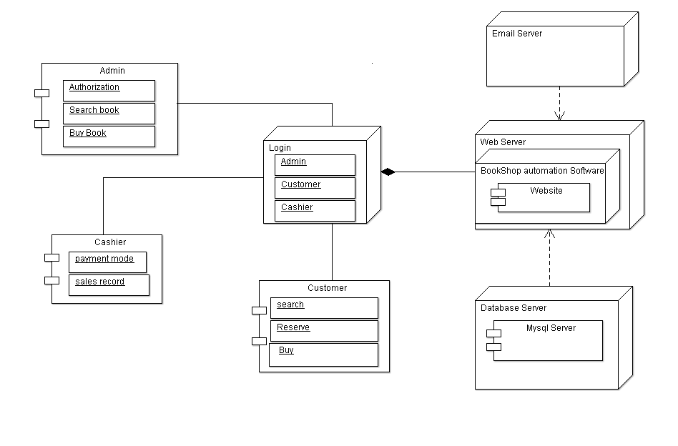

**COMPONENT** **DIAGRAM:**

